**AMORTEX INC.: END-TO-END STRATEGIC SOURCING**

This case was written by Ms Mittal Saiprabha. It is intended to be used as the basis for class discussion rather than to illustrate either effective or ineffective handling of a management situation. The author may have disguised certain names and other identifying information to protect confidentiality.

No part of this publication may be copied, stored, transmitted, reproduced or distributed in any form or medium whatsoever without the permission of the copyright owner.

# **AMORTEX INC.: END-TO-END STRATEGIC SOURCING**

# 

On the eve of a presentation to the Senior Management, Lilly Addams, the Supply Chain Manager of Amortex Inc. (Florida), sits in her cabin, weighing the options she can pitch. The company has been working with the existing third-party logistics (3PL) Partner for more than eight years, but after the recent meeting to discuss amendments to the contract, Lilly now wonders if the relationship is still profitable. However, shifting to a new vendor would come with additional costs, eating away at the company’s profits, which was the reason for her dilemma. With these questions in mind, she looks at the reports generated by the analysts in her department, hoping to come up with the most optimal solution.

## COMPANY BACKGROUND

Amortex Inc. is a Canadian pharmaceutical production company with global operations and a presence in over 100 countries. Since its incorporation in 1981, the company’s production process has been optimised over the years to efficiently produce, store and distribute high-quality generic drugs. Growing from its humble beginnings, the company now employs over 8,000 people across various verticals, including R&D, production, marketing, finance and operations. Over the last decade, with the increase in production to meet demand from the US, Amortex partnered with a prominent 3PL service provider, DOHMEN Life Sciences Services (DLSS). As per the contract, DLSS would take care of the warehousing, inventory management & distribution of its products as per the regulations of the Drug Enforcement Authority (DEA-USA). **(Exhibit 1)**

## PHARMACEUTICAL LOGISTICS INDUSTRY

Due to the increased incidence of diseases, Pharma manufacturers are growingly focussed on improving operational efficiency in production and distribution. This posed a significant opportunity for Third Party Logistics (3PL) vendors to provide services and reap profits. The global Pharmaceutical Logistics market is estimated to grow at a CAGR of 8.3% between 2020-30, reaching a valuation of USD 159.14 billion. Disruptive technologies and innovations, such as automated storage & retrieval systems, AI, blockchain, 3D printing and Big Data, are used by modern 3PL vendors to enhance performance along the supply chain.

## CURRENT STATE OF AFFAIRS

The current 3PL service provider DLSS has been providing their service to Amortex for the past 8+ years. Services rendered range from operational services like temperature-controlled storage, tele-reporting, and HAZMAT documentation; Regulatory services such as QA sampling, SOP development, quarantine release, training and maintenance; information systems access, EDI processing, and reverse logistics for returned goods and products recalled **(Exhibit 3)**.

The term for the contract commences from the date of the agreement to 48 months initially, subject to renewal every 12 months thereafter. The contract provides for termination at the will of the manufacturer, with a 30-day notice period if the increase in aggregate fee rates exceeds 5% or 2 percentage points over the increase in CPI.

## CHALLENGES FACED

The primary reason for concern is the year-on-year increase in the fee rate by the vendor, which approximates 4-5% per year, which leaves a significant dent in the bottom line of the company. Post-COVID, various governments across the globe are offering concessions on storage and warehousing to Pharma and healthcare businesses which Amortex is unable to benefit from due to its high dependency on DLSS. In addition, the operations of Amortex have been streamlined to fit the systems provided by DLSS; shifting to a new vendor would incur significant switchings costs, training and maintenance expenses (although it would be a one-time charge). If it is decided that the company should continue using the services of DLSS, then the renegotiation of terms would be a time-consuming process.

To explore available options to optimise the operations, Amortex sought to look for alternative vendors to whom they may outsource their warehousing and distribution. An RFI was floated to 9 suitable vendors, and based on the responses, 6 vendors were invited for the RFP process. Amortex received 5 responses from the shortlisted vendors (**Exhibit 2).**

The prospective vendors were evaluated on the basis of their qualitative score, pricing, and profitability/cost savings. The pricing quotes provided by each vendor and the percentage savings (or profits) offered to the firm are shown in **Exhibit 3.** The qualitative score is assigned by the analysts on the basis of seven parameters and each vendor is given an average score out of 10 **(Exhibit 4)**.

## THE DILEMMA

With the contract with DLSS nearing its renewal date, Lilly is faced with the conundrum of staying with the incumbent vendor by renegotiating the terms of the contract or shifting to a new vendor, in part or fully. For this decision, the top priority was to ensure the total cost incurred for warehousing was minimised, the budget allotted was 95% of the previous year’s baseline. The minimum qualitative score of the vendor should be maintained at least at 85%, which was the second priority of the management. Finally, the management wished to ensure the savings/profitability of 5%. For the same, penalty weights of 5,4 & 3 are assigned respectively to unfavourable deviations from the goals. In addition, to maximise the profit, a premium weight of -1 is allotted for analysis.

As she sits at her desk analysing the estimated monthly volumes **(Exhibit 6)** and the current baseline **(Exhibit 5)** after a recent mail from DLSS, indicating a 5% hike in prices for the upcoming contract year, there is a knock on Lilly’s door. James, a senior analyst from her department, enters with a bunch of reports that would help her select the right vendor(s) and optimise the supply chain.

## EXHIBIT 1

|  |  |
| --- | --- |
| Key features required by Amortex Inc. for the warehousing and distribution | |
| 1 | Temperature controlled environment |
| 2 | Warehousing management |
| 3 | Speedy distribution |
| 4 | Flexibility |
| 5 | Security |
| 6 | Reverse Logistics |
| 7 | Transportation Management |
| 8 | Load Management |
| 9 | Inventory Management |

## 

## EXHIBIT 2

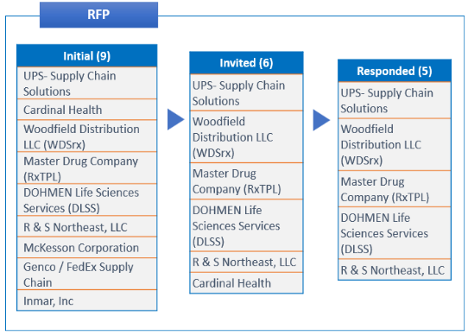

## 

## EXHIBIT 3

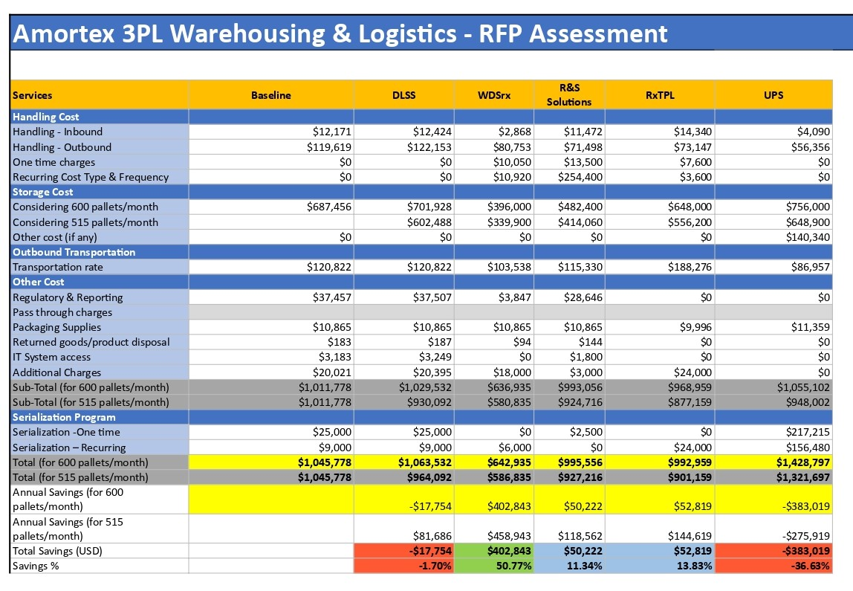

*\* Detailed RFP for each vendor given in* [*excel sheet*](https://docs.google.com/spreadsheets/d/1eOUF1OYOCnQUZ6Nz523DoOyZ_eznXrDu/edit?usp=sharing&ouid=105882450020355127408&rtpof=true&sd=true)

## EXHIBIT 4

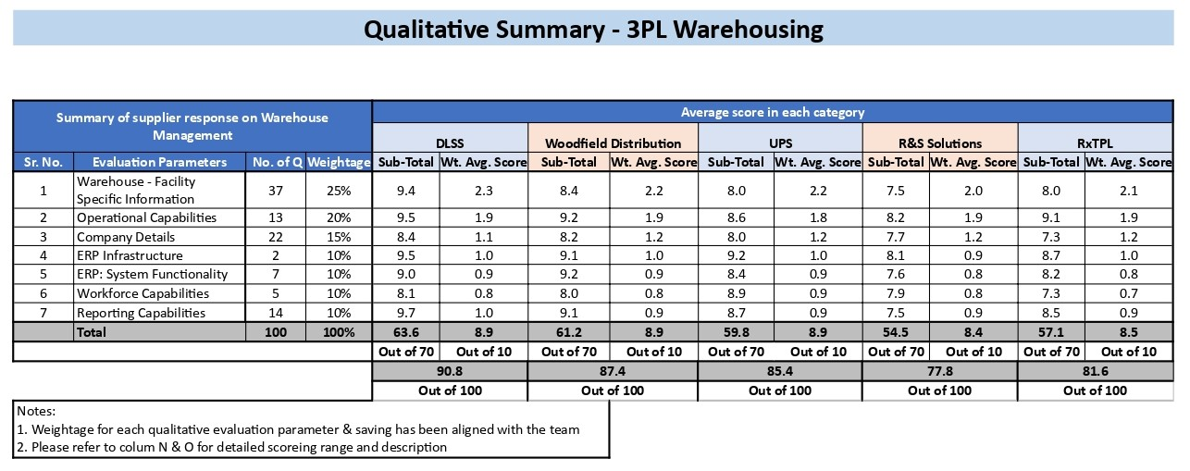

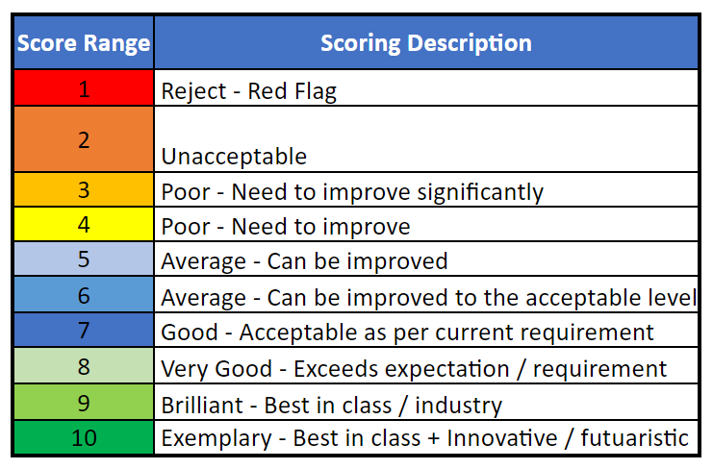

## EXHIBIT 5

|  |  |  |  |  |
| --- | --- | --- | --- | --- |
| **Baseline** | | | | |
| Description | UOM | AVERAGE ANNUAL QUANTITY | Average Monthly price | TOTAL ANNUAL SPEND |
| Storage Charge - Vault | EA | 7200 | 90.00 | $ 648,000.00 |
| Cases Shipped - Vault | EA | 28572 | 3.18 | $ 90,873.68 |
| Form 222 Processing | EA | 1099 | 25.46 | $ 27,985.97 |
| Orders Shipped - Vault | EA | 1099 | 15.91 | $ 17,488.27 |
| Account Management | EA | 12 | 1060.90 | $ 12,730.80 |
| Lines Shipped - Vault | EA | 2966 | 3.72 | $ 11,035.01 |
| Supplies | EA | 12 | 905.41 | $ 10,864.92 |
| Inbound Receiving - Quarantine | EA | 446 | 21.22 | $ 9,471.96 |
| Inbound Receiving | EA | 574 | 21.22 | $ 12,171.62 |
| 11T Carton | per unit | 2112 | 2.16 | $ 4,569.36 |
| 279 Carton | per unit | 1159 | 3.47 | $ 4,022.42 |
| Business Continuity | EA | 12 | 265.23 | $ 3,182.75 |
| IT Reporting | EA | 12 | 265.23 | $ 3,182.72 |
| Product Launch Support | SK | 2 | 795.68 | $ 1,909.62 |
| Pallet-Shipped | per unit | 499 | 2.22 | $ 1,108.22 |
| Pallet | per unit | 120 | 8.21 | $ 985.20 |
| IT Technical Support | EA | 5 | 185.66 | $ 891.17 |
| Product Destruction | EA | 2 | 154.00 | $ 369.60 |
| Orders Shipped - Broken | EA | 55 | 5.31 | $ 292.94 |
| EDI Mailbox Charges | EA | 12 | 16.95 | $ 203.40 |
| Temp-Tales Logged | EA | 24 | 7.96 | $ 191.04 |
| Return Goods Order Processing | EA | 14 | 12.73 | $ 183.31 |
| Units Shipped - Vault | EA | 593 | 0.27 | $ 160.06 |
| Return Goods Processing- Units | EA | 485 | 0.22 | $ 106.60 |
| Customer Service Order Entry | EA | 5 | 18.57 | $ 89.14 |
| Air Shipment Lab | per unit | 677 | 0.09 | $ 60.91 |
| 22 Carton | per unit | 22 | 2.79 | $ 60.36 |
| 11R Carton | per unit | 29 | 1.78 | $ 51.17 |
| Pallet-received | per unit | 497 | 0.02 | $ 9.94 |
| Return Goods Processing | EA | 17 | 2.12 | $ 35.62 |
| Orders Shipped-Destruction-Vault | EA | 2 | 12.73 | $ 30.55 |
| Units Shipped -Destruction- Vault | EA | 43 | 0.21 | $ 9.07 |
| Lines Shipped -Destruction- Vault | EA | 2 | 2.97 | $ 7.13 |
| **Total Spend** |  |  |  | **$ 862,334.55** |

## EXHIBIT 6

|  |  |  |
| --- | --- | --- |
| **Estimated Monthly Volume** | | |
|  |  |  |
| **Particulars** | **UOM** | **Quantity** |
| Pallet Storage | Pallet | 600 |
| Lines shipped | line | 247 |
| Cases shipped | Cases | 2381 |
| Form 222 processing | EA | 89 |
| Orders shipped | Orders | 92 |
| Pallet shipped | Pallet | 42 |
| Return Goods order processing | EA | 1 |
| 11T Carton | per unit | 176 |
| 279 Carton | per unit | 97 |
| Temp-tales logged | EA | 5 |
| EDI Orders | Orders | 92 |
| released from quarantine | pellet | 26 |

## 

## EXHIBIT 7

|  |  |  |  |  |  |  |
| --- | --- | --- | --- | --- | --- | --- |
| **Transportation cost** | | | | | | |
| **Type** | **Shipping type** | **DLSS** | **R&S** | **WDSrx** | **RxTPL** | **UPS** |
| **Inbound** | Standard Receipt : | $ 21.22 | $ 20.00 | $ 5.00 | $32 - Fontana warehouse  $18 - Cincinnati warehouse | $ 7.13 |
| Same business day receipt : | $ 24.37 | $ 25.00 | $ 5.00 | $32 - Fontana warehouse  $18 - Cincinnati warehouse |  |
| Receipt for same day allocation: | $ 29.24 | $ 30.00 | $ 5.00 | $32 - Fontana warehouse  $18 - Cincinnati warehouse |  |
| **Outbound** | Order | $ 15.91 | $ 18.50 | $ 5.00 | $25 - Fontana Warehouse  $15 - Cincinnati warehouse | $ 11.19 |
| Case | $ 3.18 | $ 1.50 | $ 2.50 | $25 - Fontana Warehouse  $15 - Cincinnati warehouse | $ 0.43 |
| Unit | $ 0.27 | $ 1.50 | $ 0.20 | $25 - Fontana Warehouse  $15 - Cincinnati warehouse | $ 0.20 |

## 

## EXHIBIT 8

|  |  |  |  |  |  |  |  |  |
| --- | --- | --- | --- | --- | --- | --- | --- | --- |
| **Capacity** | | | | | | | | |
| **Company** | **Locations** | **Amortex** | **DLSS** | **R&S** | **WDSrx** | **RxTPL** | **UPS** | **Client** |
| Amortex | Plainfield, IN | 200 | - | - | - | - | - | - |
| Amortex | Weston, FL | 300 | - | - | - | - | - | - |
| Amortex, DLSS & UPS | Memphis (Amortex) | 100 | 1000 | - | - | - | 1000 | - |
| RxTPL | Fontana | - | - | - | - | 600 | - | - |
| RxTPL | Cincinnati | - | - | - | - | 300 | - | - |
| R&S | Toledo | - | - | 1000 | - | - | - | - |
| WDSrx | Lockbourne | - | - | - | 332 | - | - | - |
| Client Locations | Memphis (client) | - | - | - | - | - | - | 100 |
| Client Locations | Boca Raton | - | - | - | - | - | - | 100 |
| Client Locations | Jackson | - | - | - | - | - | - | 150 |
| Client Locations | Cincinnati | - | - | - | - | - | - | 200 |
| Client Locations | Louisville | - | - | - | - | - | - | 50 |

**References**

*Pharmaceutical Logistics Market Size, Growth, Report by 2030*. (n.d.). Precedence Research. Retrieved December 12, 2022, from <https://www.precedenceresearch.com/pharmaceutical-logistics-market>

Vendor data collected from internal sources at GEP Worldwide

## PROBLEMS

1. **What are the significant issues faced by Amortex Inc.?**
2. **What are the key factors to be considered by the Supply Chain Manager while deciding the vendor mix?**
3. **Formulate the mathematical model to determine the appropriate vendor mix and, using Excel solver, identify the same while meeting the goals set by the management.**
4. **If the incumbent vendor (DLSS) changes their costs for storage and handling after negotiation to match the most optimum vendor quote, what is the impact on your decision?**
5. **Using the Network Optimisation framework and Excel solver, find the most optimum network among the selected warehouses for Amortex Inc.**
6. **Where can the costs to Amortex be reduced? Answer by undertaking an opportunity assessment.**
7. **What are your recommendations for the top management? Identify risks and challenges with each option.**